Fleste of disse bildene er fra [5.1 million+ Stunning Free Images to Use Anywhere - Pixabay](https://pixabay.com/)

vg

[-](https://www.bing.com/images/search?view=detailV2&ccid=GLSglIrk&id=5EFCA0B448D59165111B89DC49BDA5FF96E1565E&thid=OIP.GLSglIrkFDKTamJm9jvFQAHaD4&mediaurl=https%3A%2F%2Fth.bing.com%2Fth%2Fid%2FR.18b4a0948ae41432936a6266f63bc540%3Frik%3DXlbhlv%252blvUnciQ%26riu%3Dhttp%253a%252f%252f1.vgc.no%252fvgnett-prod%252fimg%252fvgLogoSquare.png%253f28042014-1%26ehk%3DRIRjeVQZgNUhzUcwvgpGmsikXz9wfVxxQRVUtn3%252bCrs%253d%26risl%3D%26pid%3DImgRaw%26r%3D0&exph=630&expw=1200&q=vg&simid=608018966051436627&FORM=IRPRST&ck=7FE00DE380B83DAC5F2B5B736C18136F&selectedIndex=0&itb=0&cw=1375&ch=664&ajaxhist=0&ajaxserp=0)

Search Image

[s](https://www.bing.com/images/search?view=detailV2&ccid=GLSglIrk&id=5EFCA0B448D59165111B89DC49BDA5FF96E1565E&thid=OIP.GLSglIrkFDKTamJm9jvFQAHaD4&mediaurl=https%3A%2F%2Fth.bing.com%2Fth%2Fid%2FR.18b4a0948ae41432936a6266f63bc540%3Frik%3DXlbhlv%252blvUnciQ%26riu%3Dhttp%253a%252f%252f1.vgc.no%252fvgnett-prod%252fimg%252fvgLogoSquare.png%253f28042014-1%26ehk%3DRIRjeVQZgNUhzUcwvgpGmsikXz9wfVxxQRVUtn3%252bCrs%253d%26risl%3D%26pid%3DImgRaw%26r%3D0&exph=630&expw=1200&q=vg&simid=608018966051436627&FORM=IRPRST&ck=7FE00DE380B83DAC5F2B5B736C18136F&selectedIndex=0&itb=0&cw=1375&ch=664&ajaxhist=0&ajaxserp=0)

photoshop

[-](https://www.bing.com/images/search?view=detailV2&ccid=ePLAd0kR&id=F997D0B9B888E442B960695FE8E37F8C27CC60AE&thid=OIP.ePLAd0kRGxUCW90PIWt7NwHaEK&mediaurl=https%3A%2F%2Flogos-world.net%2Fwp-content%2Fuploads%2F2020%2F11%2FAdobe-Photoshop-Logo.png&cdnurl=https%3A%2F%2Fth.bing.com%2Fth%2Fid%2FR.78f2c07749111b15025bdd0f216b7b37%3Frik%3DrmDMJ4x%252f4%252bhfaQ%26pid%3DImgRaw%26r%3D0&exph=2160&expw=3840&q=photoshop&simid=607999947865351780&FORM=IRPRST&ck=BECB8081020E1BE2E96DE72E5D243E75&selectedIndex=7&itb=1&cw=1375&ch=664&ajaxhist=0&ajaxserp=0)

Search

[I](https://www.bing.com/images/search?view=detailV2&ccid=ePLAd0kR&id=F997D0B9B888E442B960695FE8E37F8C27CC60AE&thid=OIP.ePLAd0kRGxUCW90PIWt7NwHaEK&mediaurl=https%3A%2F%2Flogos-world.net%2Fwp-content%2Fuploads%2F2020%2F11%2FAdobe-Photoshop-Logo.png&cdnurl=https%3A%2F%2Fth.bing.com%2Fth%2Fid%2FR.78f2c07749111b15025bdd0f216b7b37%3Frik%3DrmDMJ4x%252f4%252bhfaQ%26pid%3DImgRaw%26r%3D0&exph=2160&expw=3840&q=photoshop&simid=607999947865351780&FORM=IRPRST&ck=BECB8081020E1BE2E96DE72E5D243E75&selectedIndex=7&itb=1&cw=1375&ch=664&ajaxhist=0&ajaxserp=0)

mage

[s](https://www.bing.com/images/search?view=detailV2&ccid=ePLAd0kR&id=F997D0B9B888E442B960695FE8E37F8C27CC60AE&thid=OIP.ePLAd0kRGxUCW90PIWt7NwHaEK&mediaurl=https%3A%2F%2Flogos-world.net%2Fwp-content%2Fuploads%2F2020%2F11%2FAdobe-Photoshop-Logo.png&cdnurl=https%3A%2F%2Fth.bing.com%2Fth%2Fid%2FR.78f2c07749111b15025bdd0f216b7b37%3Frik%3DrmDMJ4x%252f4%252bhfaQ%26pid%3DImgRaw%26r%3D0&exph=2160&expw=3840&q=photoshop&simid=607999947865351780&FORM=IRPRST&ck=BECB8081020E1BE2E96DE72E5D243E75&selectedIndex=7&itb=1&cw=1375&ch=664&ajaxhist=0&ajaxserp=0)

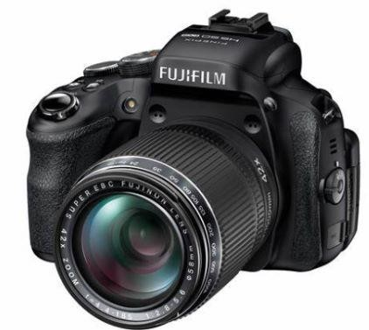

# Bilder FRA TLF

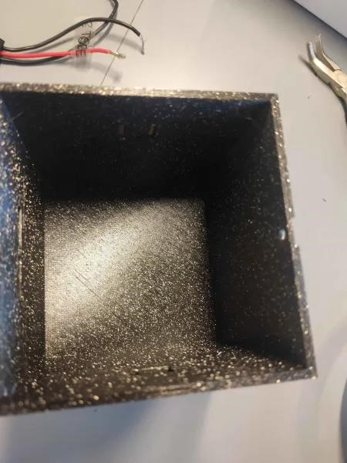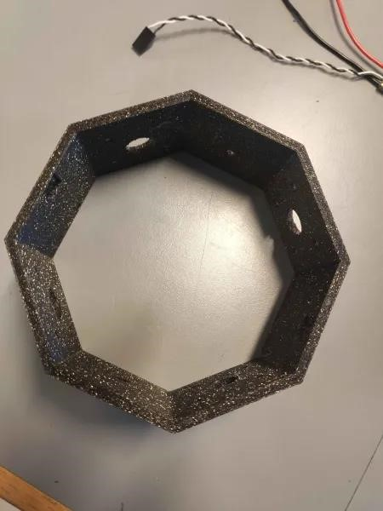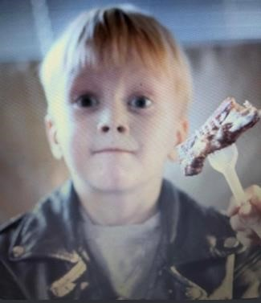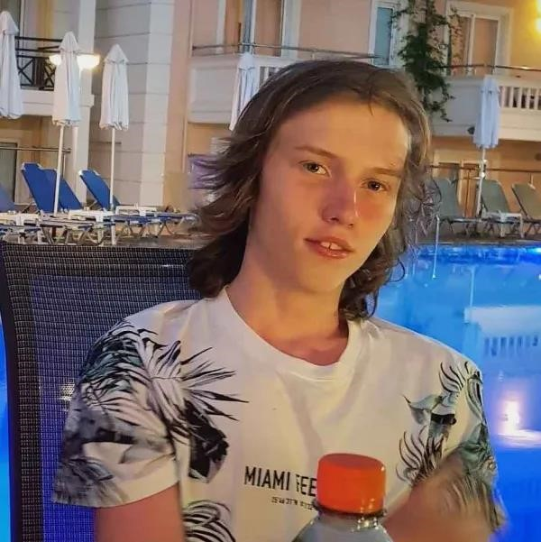

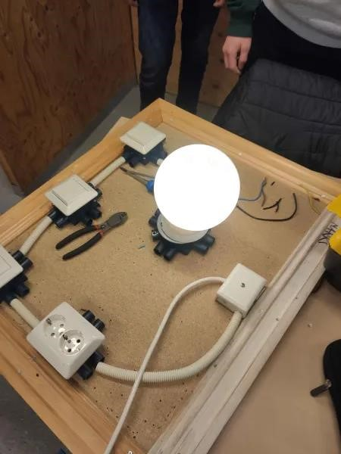

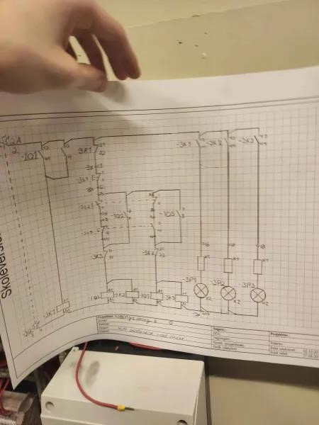

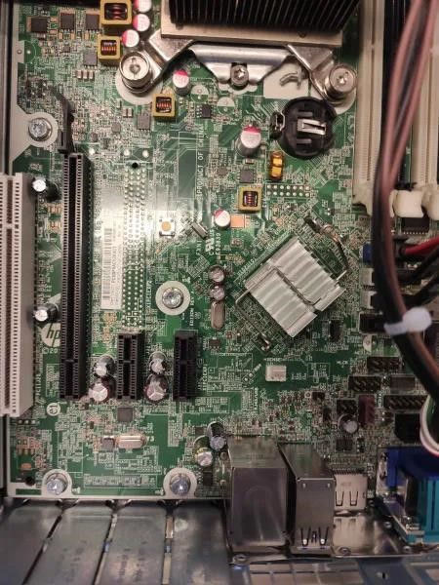

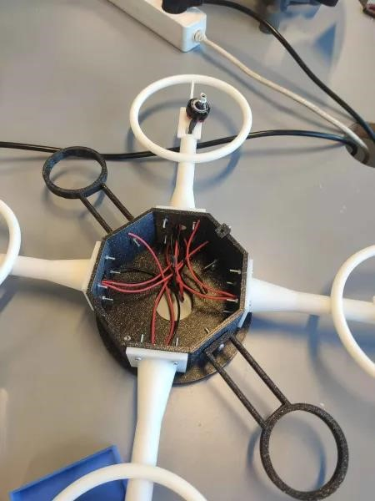

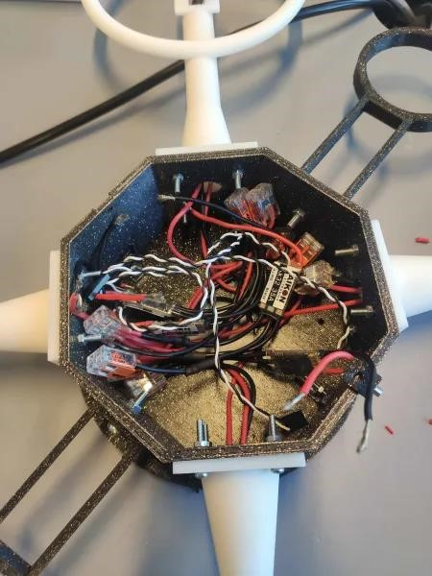

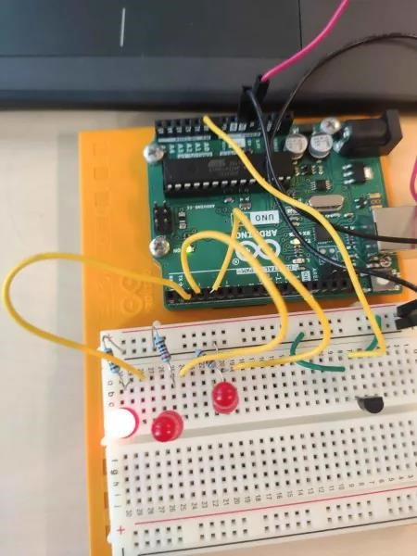

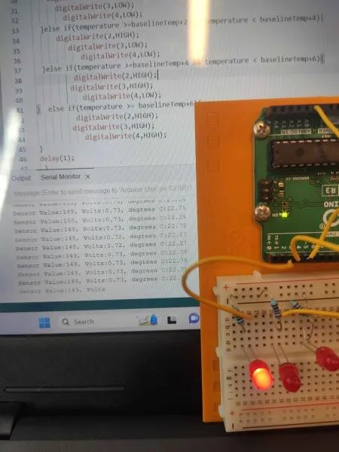

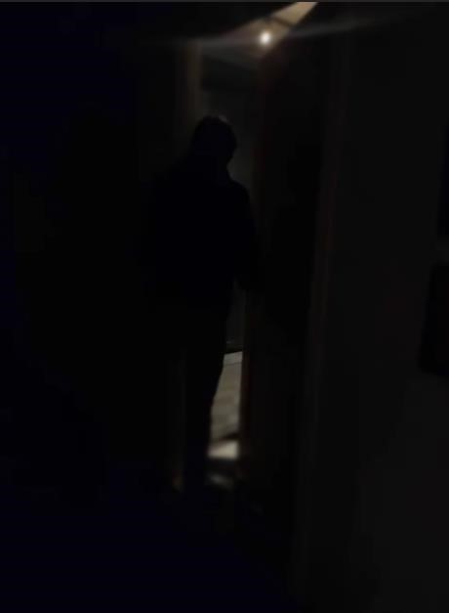

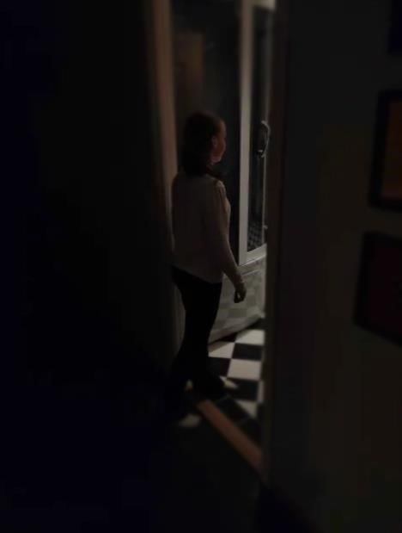

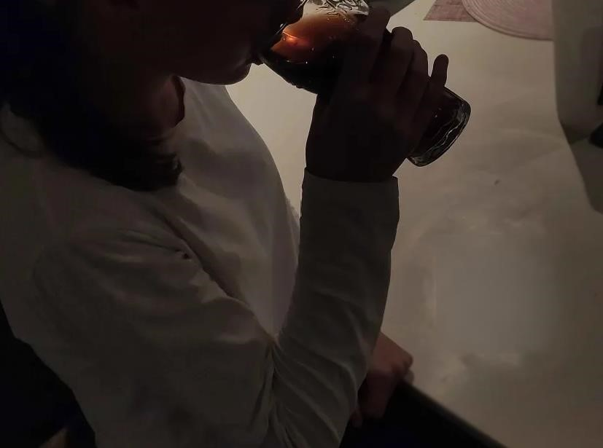

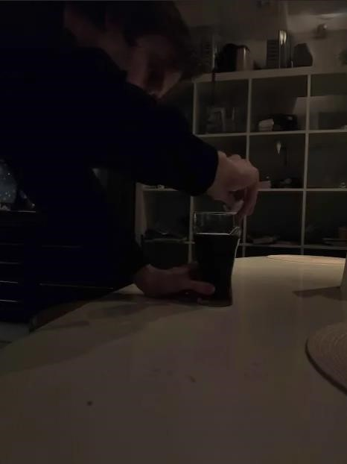

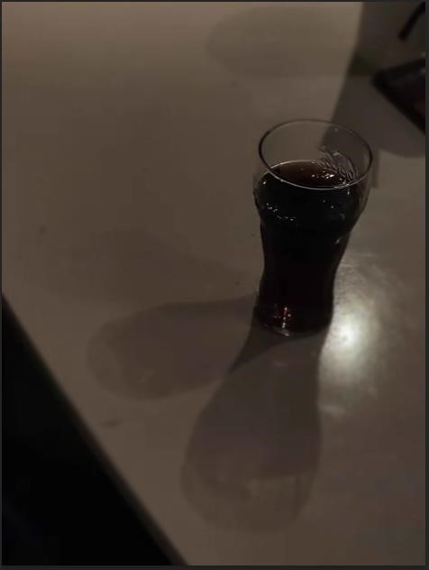

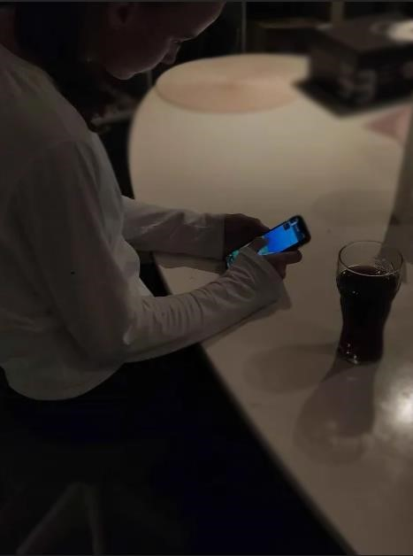

SKISSE

Eit bilete som inneheld firkant

Automatisk generert skildring

Poker Skisse

Eit bilete som inneheld skjermbilete, tekst

Automatisk generert skildring